CS-322 Software Construction

Software Requirements Specification

PULSE -HEALTH CARE INFORMATION AND APPOINTMENT SYSTEM
PRESENTED BY
Huzaifa Aousaf -04072413023 (Team Lead)
Rayyan Umer -04072413037 (Team Member 2)
Mujeeb Arshad -04072413034 (Team Member 3)
SUPERVISED BY
Dr. Onaiza Maqbool
Department of Computer Science
QUAID-E-AZAM UNIVERSITY,ISLAMABAD
07/10/2026

SRS Document Approval Signatures
Huzaifa Aousaf — Team Leader
Signature: ____________________ Date: ____________________
Rayyan Umer — Team Member
Signature: ____________________ Date: ____________________
Mujeeb Arshad — Team Member
Signature: ____________________ Date: ____________________
Dr. Onaiza Maqbool — Supervisor
Signature: ____________________ Date: ____________________

Change History
Version | Date | Changes
1.0 | 07/10/2026 | Updated the sample SRS for PULSE using the project documentation, combined use case texts and domain model.
1.1 | 07/10/2026 | Arranged the sections and use cases in order. Removed the data dictionary and extra interface section.

Remarks
_________________________________________________________________
_________________________________________________________________

Table of Contents
1. Introduction
1.1 Purpose
1.2 Scope
1.3 Definitions, Acronyms and Abbreviations
1.4 References
1.5 Overview
2. Overall Description
2.1 Product Perspective
2.2 Product Functions
2.3 User Characteristics
2.4 Constraints
2.5 Assumptions and Dependencies
3. Specific Requirements
3.1 Functional Requirements (Use Cases)
3.2 Non-Functional Requirements
3.3 System Functions
3.4 Performance Requirements
4. Supplementary Material
4.1 Domain Model
4.2 Use-case Diagram

1. Introduction

1.1 Purpose
The PULSE System aims to:
Develop a healthcare management system for managing doctors and patient’s info.
To allow users to search for doctors based on specialization, symptoms and location.
To Provide doctor’s details and schedules to user.
To allow patients to book physical or online appointments with doctor.
To allow users to search and access laboratory test results online.
To provide a single platform for convenient healthcare services.
To efficiently manage and maintain doctor and patient info.

1.2 Scope
User Registration.
Record and manage doctor’s and patient’s information.
Search for doctor’s details.
Define and Update schedules.
Make an appointment (Physical or Online).
Search for Lab Tests and Results.
User Login and Authentication.
Manage disease information.
Make online payments.
Upload lab test results.
Provide online diagnosis.
Manage User Accounts.

Project Name
PULSE -HEALTH CARE INFORMATION AND APPOINTMENT SYSTEM

Main Functionality
The ‘PULSE’ is a web-based healthcare platform that provides information about doctors and diseases. The system allows registered users and doctors to create and manage doctor profiles containing details such as specialization and location. Users can search for doctors based on symptoms, specialization, and area. The platform supports online appointment booking, online consultations, electronic prescriptions, and secure online payments. Registered users can also view their laboratory test results online after testing. The system aims to improve access to healthcare services and provide a centralized, secure, and user-friendly healthcare management platform

Objectives
The goal is to develop a Health Care System for managing the following:
Store and manage doctors’ information, including their specialization, experience, location, availability, and contact details.
Provide a simple and responsive interface that allows patients to easily search for doctors and access healthcare services.
Enable users to search for doctors based on specialization, symptoms, and location.
Implement an online appointment booking system that allows registered users to book appointments with registered doctors.
Manage patient information securely, including personal details and appointment records.
Provide online access to laboratory test results, allowing patients to view their reports conveniently.
Provide disease-related information to help users understand diseases and their common symptoms.
Secure the system with authentication and role-based access control to protect patients’ and doctors’ information.
Manage doctors’ availability and appointment schedules to reduce conflicts and improve appointment management.

1.3 Definitions, Acronyms and Abbreviations
SRS: Software Requirements Specification.
Patient: A registered user who can search for doctors, book appointments, view prescriptions, and access lab test results.
Doctor: A healthcare professional who can create and manage a profile, provide consultations, issue prescriptions, and manage appointments.
Disease Information: Medical information related to diseases, symptoms, causes, and treatments available on the platform.
Appointment: A scheduled meeting between a patient and a doctor for consultation or physical checkup.
Online Consultation: A remote medical consultation conducted through the system.
Electronic Prescription: A digital prescription issued by a doctor and made available to the patient through the platform.
Lab Test Result: A medical test report uploaded by an authorized laboratory and accessible to the patient online.
Doctor Profile: A record containing a doctor's information, including specialization, experience, qualifications, and location.
Authentication: The process of verifying a user's identity before granting access to the system.
Online Payment: A secure electronic transaction made through the platform for consultation or service fees.
Lab Technician: The lab technician uploads a patient’s lab test report so the patient can view it online.
Administrator: The administrator creates user accounts and updates their details, roles or account status.

1.4 References
Pulse Documentation version 1.docx — Project documentation.
USE CASES ALL.docx — Use case texts and inputs/outputs.
Sample SRS.docx — Supplied SRS template.
DOmain Model.jpeg — Domain model.
USE CASE DIAGRAM.png — Use-case diagram.
IEEE Standard for Software Requirements Specifications (IEEE Std 830-1998), as listed in the supplied SRS template.

1.5 Overview
This document includes the introduction, overall description and specific requirements of PULSE. The use case texts include inputs and outputs. The analysis models are included in the supplementary material.

2. Overall Description

2.1 Product Perspective
The ‘PULSE’ is a web-based healthcare platform that provides information about doctors and diseases. The system allows registered users and doctors to create and manage doctor profiles containing details such as specialization and location. Users can search for doctors based on symptoms, specialization, and area. The platform supports online appointment booking, online consultations, electronic prescriptions, and secure online payments. Registered users can also view their laboratory test results online after testing. The system aims to improve access to healthcare services and provide a centralized, secure, and user-friendly healthcare management platform

2.2 Product Functions
User Registration.
Record and manage doctor’s and patient’s information.
Search for doctor’s details.
Define and Update schedules.
Make an appointment (Physical or Online).
Search for Lab Tests and Results.
User Login and Authentication.
Manage disease information.
Make online payments.
Upload lab test results.
Provide online diagnosis.
Manage User Accounts.

2.3 User Characteristics
Patient: A registered user who can search for doctors, book appointments, view prescriptions, and access lab test results.
Doctor: A healthcare professional who can create and manage a profile, provide consultations, issue prescriptions, and manage appointments.
Lab Technician: Uploads lab test results for the selected laboratory.
Administrator: Manages user accounts and disease information.
Users need basic knowledge of using a website.

2.4 Constraints
The project must be completed within the academic semester.
The system requires a stable internet connection for consultations, appointment booking, payments, and accessing medical records.
Only authenticated and registered users will be allowed to book appointments, make payments, and view prescriptions or lab reports.
The system must ensure the confidentiality and security of patient, doctor, and payment information.
Online payment functionality will depend on the availability and integration of third-party payment gateways.
Online consultation quality may be affected by users' internet bandwidth and device capabilities.
Electronic prescriptions can only be issued by verified doctors registered on the platform.
The accuracy of doctor profiles, disease information, and lab results depends on the data provided by authorized users and healthcare providers.
The system will be developed as a web-based application and may have limited support for older browsers and devices.
Development resources, budget, and team size are limited to those available within the university project environment.

2.5 Assumptions and Dependencies
Users (patients, doctors, and lab technicians) will have reliable internet access to use the system.
Patients will actively engage with the platform and provide timely feedback on checkup.
The system will be accessible to patients and doctors online.
Patients will search for doctor according to his issue/disease.
Doctor information is available on the application. (includes location, specialization, fee, contact etc.)
Users will contact doctors online via application or make an appointment for physical checkups.
Users will search and make appointments for lab tests and see results online.
Online payment functionality will depend on the availability and integration of third-party payment gateways.
The accuracy of doctor profiles, disease information, and lab results depends on the data provided by authorized users and healthcare providers.

3. Specific Requirements

3.1 Functional Requirements (Use Cases)
Division of Use Cases
Group Member | Use Cases
Huzaifa Aousaf | Search for doctor; Manage doctor profile; Manage patient profile; Online Diagnosis
Rayyan Umer | Make Appointment; Update/Define Schedule; Make Payment; Manage disease Information
Mujeeb Arshad | Search for Lab Test; Upload Lab Test Results; View Lab Test Results; Manage User Accounts

UC 01: Search for doctor
Member Name: Huzaifa Aousaf
Primary Actor:
Patient , user
Secondary actor:
Doctor , Patient
Description:
Allow users to search for available doctors based on criteria such as specialty , location , availability or name and specialization.
Preconditions:
System database contains registered and active doctor’s profile .
The user has selected or provided a location preference via select location use case.
Post conditions:
The user views a list of matching doctors along with details.
Users can select doctors for appointments.
Main success scenarios:
Users search for a doctor.
System displays the doctor’s search interface with search filters.eg. specialty, doctor name , distance, fee ranges.
Users enter a search criteria or leave blank browser to browse all and check search.
System validates the search parameters and queries, the database for matching doctor profiles.
System displays list of matching doctors along with their credentials, location , fee , and specialty.
Users select doctor profile to view details or proceed to booking.
Alternate scenarios:
User leaves all search fields blank.
System displays all available doctors based on the selected location.
System finds no doctor matching the entered criteria.
User enters invalid information, such as an invalid name or fee range.
System displays an error message.
A matching doctor is found but is currently unavailable for appointments.
User has not provided a location preference.
Inputs of Use Case | Outputs of Use Case
Patient ID  Search criteria  Doctor specialization  Symptoms  Location  Doctor name  Fee range | Doctor details  Doctor specialization  Doctor’s experience and qualifications  Doctor location  Doctor fee  Doctor availability  Matching doctor list  Search result/status

System Sequence Diagram: Search for Doctor
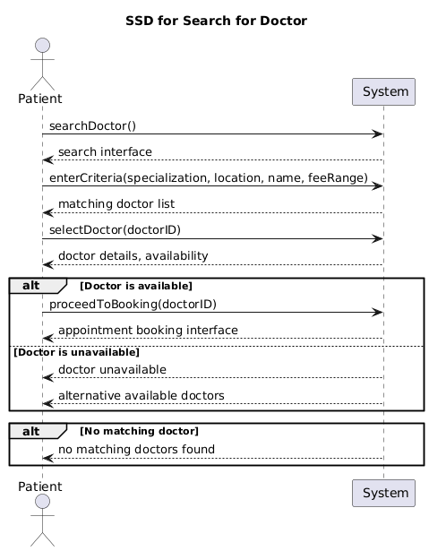

UC 02: Make Appointment
Member Name: Rayyan Umer
Primary Actor: Patient
Description: This describes how patients can make appointments with doctors through Pulse Healthcare Information and Appointment System. The patient searches for doctor, select doctor and select appointment
Pre-Condition:
Patients must login to the System
Patients can access the appointments
Post-Condition:
Appointment Successful
Appointment Details are saved
Patients view the details of the appointment
Main Success Scenario:
Patient logs into the website.
Patient selects Make Appointment.
Patients search for a doctor by specialization, symptoms, or location.
System displays the available doctors.
Patients select a doctor.
System displays the doctor’s available dates and time slots.
Patients select a suitable date and time.
Patient confirms the appointment.
System saves the appointment and displays a confirmation message
Alternate Scenario 1: (When Slot is Not Available)
Patients select a doctor and a time slot.
System checks the availability of the selected slot.
The selected slot is no longer available because another patient has booked it.
System displays a message: “This time slot is no longer available.”
System displays other available time slots.
Patients select another available time slot.
Patient confirms the appointment.
System successfully books the appointment and displays the confirmation.
Alternate Scenario 2: (When Doctor is Not Available)
Patient search for a doctor.
System finds that the selected doctor has no available appointments.
System displays “No appointments available for this doctor.”
System suggests other available doctors.
Patient selects another doctor.
Patient selects an available date and time.
System books the appointment successfully.
Inputs of Use case: | Output of the Use case:
Patient ID  Doctor ID  Symptoms  Location  Appointment Date  Appointment Time  Appointment Confirmation | Doctor Details  Available Dates  Available Time  Appointment Details  Appointment Status

System Sequence Diagram: Make Appointment
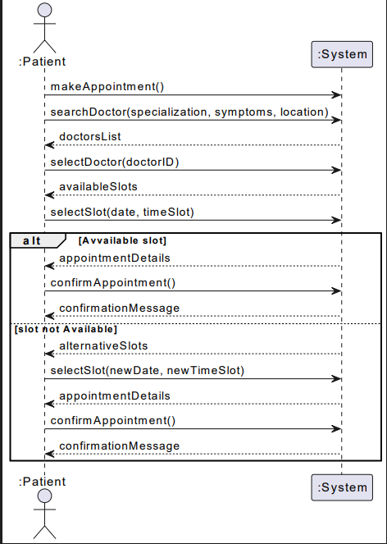

UC 03: Search for Lab Test
Member Name: Mujeeb Arshad
Primary Actor: Patient
Preconditions:
The patient is logged into the PULSE system.
The system has an active internet connection.
Post-Conditions:
The patient successfully finds the lab test they need.
The patient can proceed to book an appointment or view past results for that test.
Main Success Scenario:
The patient clicks "Search for Lab Tests" from the main menu.
The system shows a search menu with filters (test name, category, lab name, location).
The patient enters their search details and clicks "Search".
The system shows a list of matching tests, including the lab name, location, price, and preparation instructions.
The patient clicks on a specific lab test to see more details.
The system shows the full details and gives options to "Book Appointment" or "View Past Records".
Alternate Flow 1: No Records Found
The patient enters their search details and clicks "Search".
The system finds no lab tests matching the search.
The system shows a message: "No lab tests found matching your criteria."
The system suggests common alternative tests and provides a button to clear the filters.
Alternate Flow 2: User Leaves Search Fields Blank
The patient leaves all search filters blank and clicks "Search".
The system displays a complete list of all available lab tests across all locations.
Alternate Flow 3: User Enters Invalid Information
The patient enters invalid characters into the search fields.
The system displays an error message asking the user to enter valid text.
Inputs: | Outputs:
Test name  Category  Laboratory Name  Location | Test Name  Laboratory Name  Location  Price  Availability

System Sequence Diagram: Search for Lab Test
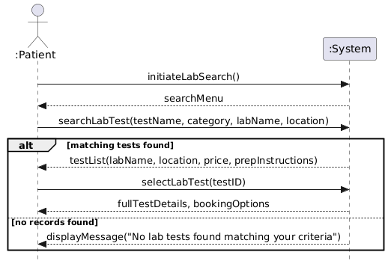

UC 04: Update/Define Schedule
Member Name: Rayyan Umer
Primary Actor: Doctor
Description:Doctor update the schedule so that user can view the available schedule
Pre-Condition:
Doctor must be login to the system
Doctor must access to the schedule part
Post-Condition:
Schedule is successfully added and updated
Schedule details are saved in the system
Updated Schedule is displayed on the system
Main Success Scenario:
Doctor login into the system
Doctor selects define/update schedule
System displays the existing doctor schedule
Doctor select new schedule or sselect existing schedule
Doctor enters the schedule dates ,start time and end time
System checks the entered schedule information
Doctor Confirms the schedule
System saves the new updated schedule
System displays schedule updated successfully
Alternate Scenario 1:(Invalid Schedule Information)
Doctors enter invalid date or time
System validates the schedule information
System displays invalid date and time Please enter valid info
Doctor corrects the schedule information
System saves the schedule successfully
Alternate Scenario 2:(Schedule Conflict)
Doctors enters the new time slot
System checks the schedule
System finds conflict with the existing schedule
System dislplays Choose another time
Doctors selects another schedule
System displays schedule is updated successfully
Inputs of the use case: | Output of the use case:
Schedule date  Start time  End time  Schedule status | Available Schedule  Updated Schdule  Schedule confirmation message

UC 05: Make Payment
Member Name: Rayyan Umer
Primary Actor: Patient
Description: This describes how a patient makes payment ,system saves the details and shows payment successful
Pre-Condition:
Patient must be login into the system
Patient must have confirmed appointment
Payment slip must be available
Post-Condition:
Payment is successfully Completed
Payment details are saved
Patient receives confirmation message
Main Success Scenario:
Patient logs into the website
Payment selects make payment
System displays the payment
Patient selects appointment
System displays the required amount
Patient put required information about payment
System validates the payment
Patient confirms the payment
System saves the payment details
Alternate Scenario1:(Payment Failed)
Patient enters payment information
Patient confirms the payment
System process the payment
System displays payment failed please enter valid details
System processes again
System displays message confirmation of payment
Alternate Scenario2:(Invalid Payment information)
Patient enters payment information
System checks the payment information
System displays information is invalid
Patient enters information again the valid information
System displays payment confirmation
Inputs of the use case: | Output of the use case:
Payment method  Payment information  Payment confirmation | Payment status  Payment receipt  Payment details

UC 06: Manage disease Information
Member Name: Rayyan Umer
Primary Actor: Admin
Description: This describes how an admin adds or update the disease information in the pulse system.
Pre-Condition:
Admin must login into the system
Admin must have access to the disease management part
Post-Condition:
Disease information is successfully added or updated
Disease details are saved in the system
Main Success Scenario:
Admin logs in the system
Admin selects the disease management option
System displays the information of disease
Admin selects add or update the disease
System validates the information
Admin confirms the information
System saves the information about the disease
System displays successful message
Alternate Sccenario 1:(Disease Inforamtion Already exists)
Admin enters the disease name
System check the existing disease record
System finds the record already exists
System displays record already exists
System provides option to update the record
Admin update it and system displays record is updated now
Alternate Scenario 2:(Invalid Information)
Admin enters disease information
System validates the information
System displays information is invalid please enter information again
Admin enters information again
System saves the disease information successfully
Input of the use case: | Output of the use case:
Disease name  Symptoms  Causes  Treatment Information | Updated disease information  Disease info confirmation message

UC 07: Upload Lab Test Results
Member Name: Mujeeb Arshad
Primary Actor:
Lab Technician
Description:
The lab Technician uploads a patient’s lab test report so the patient can view it online.
Preconditions
The lab technician is logged into the system.
The patient and the lab test record exist in the system.
The lab technician is allowed to upload results for the selected laboratory.
Post-Conditions
The report is saved against the selected patient and lab test record.
The patient can view the uploaded result.
Main Success Scenario:
The lab technician selects “Upload Lab test results”.
System asks for the patient ID and lab test record.
The lab technician enters the patient ID and selects the lab test record.
System displays the patient name,test name and test date.
The lab technician checks these details , enters the report date and selects the report file.
The lab technician clicks “Upload”.
System saves the report with the patient , test record and uploading technician details.
System displays “ Lab test result uploaded successfully”.
Alternate Scenario1 : Patient or Test Record Not Found
System finds no matching patient or test record.
System displays “ Patient or test record not found”.
The lab technician checks the ID and selects the correct record.
Alternate Scenario1 : Missing Details or Invalid File
System finds a missing field , an unsupported file type.
System displays the problem and ask the lab technician to correct it.
The lab technician corrects the details or selects a valid file and upload again.
Inputs of Use Case: | Outputs of Use Case:
Patient ID  Lab test record ID  Report Date  Report file | Patient and test details  Saved lab test results  Upload status

UC 08: View Lab Test Results
Member Name: Mujeeb Arshad
Primary Actors
Patient or Authorized Doctor
Description
The patient views their lab test results uploaded by the laboratory.
Preconditions
The patient or doctor is logged into an active PULSE account.
A doctor must be allowed to access the selected patient’s results.
Post-Conditions:
The patient or authorized doctor views the selected lab test result.
The saved report remains unchanged.
Main Success Scenario
The patient selects “View Lab Test Results”.
System displays the patient’suploaded results with name, laboratory name and report date.
The patient selects a lab test result.
System checks that the result belongs to the logged in patient.
System opens the report and displays the test details and result.
Alternate Scenario 1: Doctor Views a Patient’s Result (Step 1)
1. The doctor opens a patient record they are allowed to access and selects “View Lab Test Results”.
2. System checks the doctor’s permission for that patient.
3. System displays the patient’s uploaded results.
4. The doctor selects a result and system opens the report.
5. If permission is not available, system denies access and does not display the report.
Alternate Scenario 2: No Results Available (Step 2)
1. System finds no uploaded results for the patient.
2. System displays “No lab test results available.”
Inputs of Use Case: | Outputs of Use Case:
Patient ID from the logged in account, or an authorized patient record.  Selected lab test result ID. | List of patient’s lab test results.  Test name and laboratory name  Report date  Selected report  Result status

UC 09: Manage User Accounts
Member Name: Mujeeb Arshad
Primary Actor
Administrator
Description
The administrator creates user accounts and update their details,roles or account status.
Preconditions
The administrator is logged into an active administrator account.
Post-Conditions
The new account or changes to the selected account are saved.
The account can only access the functions allowed by its role and status.
Main Success Scenario:
The administrator selects “Manage User accounts”.
System displays the user list and account search option.
The administrator searches for a user and selects the account.
System displays the user’s name,email,role and account status.
The administrator updates the required details and clicks “Save”.
System checks the details and the administrator permission.
System saves the changes and records who made the change and when.
System displays “User account updated successfully”.
Alternate Scenario : Create New Account
The administrator selects “Create Accounts”.
System displays the account form.
The administrator enters the name,email,initial password and role, then clicks “Save”.
System checks the details and creates the account if they are valid.
System displays “ User account created successfully”.
Alternate Scenario : Deactivate or Reactivate Account
The administrator selects “Deactivate” or “Reactivate”.he
System asks the administrator to confirm.
The administrator confirms and system updates the account status.
A deactivated account cannot login or continue an existing session.
Inputs of Use case: | Outputs of Use Case:
User ID or search details  Name  Email  Role  Account Status  Initial Password for a new account. | User Account list  Account details  Updated role or account status  Confirmation or error message.

UC 10: Manage doctor profile
Member Name: Huzaifa Aousaf
Primary Actor:
Doctor
Description:
The doctor adds or updates their professional details so patients can view the profile when search for a doctor.
Preconditions:
The doctor is logged inyo an active doctor account.
The doctor is allowed to manage their own profile
Post conditions:
The doctors profile details are saved.
The updated details are shown when a patient views doctor profile .
Main Success scenario:
The doctor selects .”manage doctor profile .”
System displays the doctor current profile details .
Doctor selects .”edit profile .”.
The doctor enters or updates their specialization ,qualification and their other details ,
The doctor clicks on save .
System checks the required details and entered values .
System saves the changes and display doctor profile updated successfully.
Alternate Scenerio:
The doctor has not added their profile details .
System displays an empty profile form.
Doctor enters the required details and clicks save
System checks and save the profile , than displays a confirmation message .
Alternate scenario 2;
Doctor selscts cancel instead of save.
System returns to saved profile without applying changing.
Inputs of use case : | Outputs of Use Case:
Doctor ID from the logged-in account  Specialization  Qualifications  Years of experience  Location  Contact number  Consultation fee | Doctor profile details  Updated profile  Confirmation or error message

UC 11: Manage patient profile
Member Name: Huzaifa Aousaf
Primary actor :
Patient .
Description:
Patient adds or update their personal details in the pulse system.
Preconditions:
The patient is logged into an active patient account.
Patient is allowed to manage their own profile.
Post condition:
The patient profile details are saved.
The patient can view the updated details .
Main success scenario:
The patient selects “Edit Profile”.
System displays the patient’s current profile details.
The patient selects “Edit Profile”.
Patient enters or update their names and contact and other details .
Patient ckicks on save .
System checks the trequired details and entered values
System save changes and display patient profile updated successfully.
Alternate Scenario 1: Complete Profile
Some profile details have not been added yet.
System displays the available details and empty fields.
The patient enters the missing details and continue.
Alternate Scenario 2: Missing or Invalid Details
The patient leaves a required field blank or enters an invalid value , such as a future date of birth.
System identifies the field and ask the patient to correct it
The patient corrects the details and clicks on save again.
Inputs of use case : | Outputs of Use Case:
Patient ID from the logged-in account  Patient name  Contact number  Date of birth  Address | Patient profile details  Updated profile  Confirmation or error message

UC 12: Online Diagnosis
Member Name: Huzaifa Aousaf
Primary Actor:
Doctor
Secondary Actor
Patient
Description
The doctor consults the patient online and records the diagnosis and prescription,if needed.
Preconditions
The doctor and patient are logged into active PULSE accounts.
The patient has an online appointment with the doctor.
The scheduled appointment time has arrived.
Post-Conditions
The consultation details and doctor’s diagnosis are saved against the appointment.
Any prescription issued by the doctor is available to the patient.
The completed consultation is marked as completed.
Main Success Scenario
The doctor selects the scheduled online appointment.
System displays the appointment details and the option to join the consultation.
The doctor and patient join the online consultation.
The patient explains their symptoms and answer’s the doctor’s questions.
The doctor discusses the symptoms and enters the diagnosis.
The doctor enters a prescription and instructions,if needed.
The doctor reviews the details and selects “Save and Complete”.
System checks and saves the consultation details against the appointment.
System marks the consultation as completed and makes any prescription available to the patient.
Alternate Scenario 1: Patient has not joined
System shows that the patient has not joined the consultation.
The doctor can wait for the patient and continue when they join.
If the consultation does not take place, system does not mark it as completed.
Alternate Scenario 2: Connection Fails
The doctor or patient loses the connection.
System displays a connection error and allows them to rejoin.
If they reconnect consultation continues. If not, the consultation remains incomplete.
Inputs of Use Case: | Outputs of Use Case
Appointment ID  Doctor ID  Patient ID  Patient Symptoms | Consultation details  Doctor’s Diagnosis or advice  Consultation status

3.2 Non-Functional Requirements

Performance Requirements
The system should display doctor searches, lab test searches and saved profile details within 2–3 seconds under normal conditions.
The system should allow patients, doctors, lab technicians and administrators to use it at the same time.
The system should show updated appointment, payment and lab result status after the details are saved.

Security Requirements
Only authenticated and registered users will be allowed to book appointments, make payments, and view prescriptions or lab reports.
The system must ensure the confidentiality and security of patient, doctor, and payment information.
The system should check the user’s role before allowing access to a function.
Patients can view their own lab results. A doctor must be allowed to access the selected patient’s results.
A deactivated account cannot login or continue an existing session.
Electronic prescriptions can only be issued by verified doctors registered on the platform.

Usability Requirements
The system should use clear menus and simple forms.
The system should show a clear message when information is missing or invalid.
The system should be usable on a computer or mobile phone.
The system should show confirmation after information is saved.

Reliability Requirements
The system should keep backups of saved information to prevent data loss.
The system should allow saved information to be restored after a system failure.
If a lab report cannot be uploaded, the system should show an error and allow the lab technician to try again.
The system should not confirm a doctor’s time slot if it is already booked by another patient.

3.3 System Functions

Manage User Accounts
The administrator enters the name,email,initial password and role, then clicks “Save”.
System checks the details and creates the account if they are valid.
The administrator updates the required details and clicks “Save”.
System saves the changes and records who made the change and when.

Manage Doctor Profile
The doctor enters or updates their specialization ,qualification and their other details ,
System checks the required details and entered values .
System saves the changes and display doctor profile updated successfully.

Manage Patient Profile
Patient enters or update their names and contact and other details .
System checks the trequired details and entered values
System save changes and display patient profile updated successfully.

Search for Doctor
System displays the doctor’s search interface with search filters.eg. specialty, doctor name , distance, fee ranges.
System validates the search parameters and queries, the database for matching doctor profiles.
System displays list of matching doctors along with their credentials, location , fee , and specialty.

Make Appointment
System displays the doctor’s available dates and time slots.
Patient confirms the appointment.
System saves the appointment and displays a confirmation message

Search for Lab Test
The system shows a search menu with filters (test name, category, lab name, location).
The system shows a list of matching tests, including the lab name, location, price, and preparation instructions.
The system shows the full details and gives options to "Book Appointment" or "View Past Records".

Update/Define Schedule
Doctor enters the schedule dates ,start time and end time
System checks the entered schedule information
System saves the new updated schedule

Make Payment
System displays the required amount
System validates the payment
System saves the payment details

Upload Lab Test Results
System asks for the patient ID and lab test record.
System displays the patient name,test name and test date.
System saves the report with the patient , test record and uploading technician details.

View Lab Test Results
System displays the patient’suploaded results with name, laboratory name and report date.
System checks that the result belongs to the logged in patient.
System opens the report and displays the test details and result.

Online Diagnosis
The doctor discusses the symptoms and enters the diagnosis.
The doctor enters a prescription and instructions,if needed.
System checks and saves the consultation details against the appointment.
System marks the consultation as completed and makes any prescription available to the patient.

Manage disease Information
Admin logs in the system
Admin selects add or update the disease
System validates the information
System saves the information about the disease

3.4 Performance Requirements
Response time: The 2–3 second response time is a target adapted from the sample SRS. It applies to doctor searches, lab test searches and saved profile details under normal conditions. The target will be checked during testing.
Lab report upload time and online consultation quality depend on the user’s internet connection and the file size. The submitted project documents do not set a user limit, upload time limit or recovery time limit.

4. Supplementary Material

4.1 Domain Model
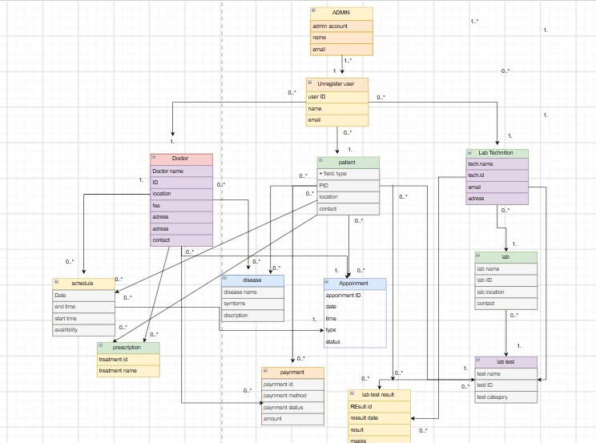

4.2 Use-case Diagram
